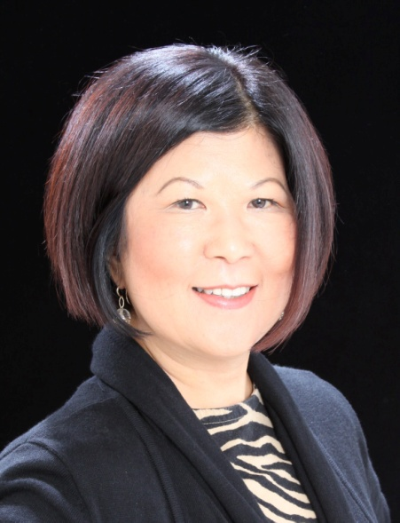
Dr. Lori Adrian
President, Coastline College

Dr. Adrian joined the Coast Community College District as the sixth president of Coastline Community College on July 1, 2010. Coastline is one of the three colleges in the Coast District. Founded originally as a “college without walls,” Coastline is one of the nation’s most innovative colleges and is deeply committed to a “students-first” philosophy. Coastline currently has three campuses in Orange County. A beautiful and sustainable new campus will open in Newport Beach in July 2012. Coastline brings on-site and hybrid classes to students close to their homes locally, and through Distance Learning nationally and internationally.
Dr. Adrian has been as an educational leader for over thirty years. During her first year of tenure as president, some of her outstanding accomplishments include the completion of an educational master plan for the college, in collaboration with the faculty, staff, students, and external stakeholders. She supported leadership development and led the college through a financially challenging time in an atmosphere of mutual respect, and open and transparent communication. She is sharply focused on student success and the practice of a “students first” philosophy. Prior to joining Coastline, she served as the vice president of student services at Skyline College in the Bay Area from 2005-10. As the chief student services officer, Dr. Adrian provided leadership for a comprehensive array of student service programs aimed at facilitating student success and fostering a strong connection to diverse students. In collaboration with instruction, she developed and implemented student-centered programs and services, e. g., learning communities for Latino, African-American, and Filipino students. She provided leadership for the Foundations of Excellence in the First Year Experience Project, which subsequently informed Skyline’s Basic Skills’ self-study and the College Success Initiative. From Nov 1992-Aug 2005, Dr. Adrian worked as dean of student affairs, interim dean of student development and matriculation, and acting vice president of student services at San Diego Mesa College. Dr. Adrian spent ten years of her career working with international students from around the world, both at the University of the Pacific (a private four-year university) and at San Joaquin Delta College (a community college), in Northern California. She worked closely with foreign embassies and educational foundations in Washington DC, and with Ministries of Education worldwide.
In addition to her U.S. higher education background, Dr. Adrian worked as an intercultural trainer/project director for the U. S. Peace Corps for six years. She designed and managed cultural, linguistic, and technical orientation and retraining programs for American Peace Corps volunteers who were assigned to the Philippines. Working with a prominent linguistics scholar, she helped develop dictionaries in English and various Philippine languages, and documented the oral literature of diverse Philippine ethno-linguistic groups. These experiences provided a strong foundation for her commitment to global education, intercultural competencies and diversity.
Dr. Lori Adrian holds a Doctor of Philosophy (Ph.D.) in Education from Claremont Graduate University. She has a master’s degree in Communication Theory from the University of the Pacific and a bachelor’s degree in Philippine Studies from the University of the Philippines, with a minor in linguistics.

